Issues Faces –

1. Site not loading

Solution –

Commented few lines.

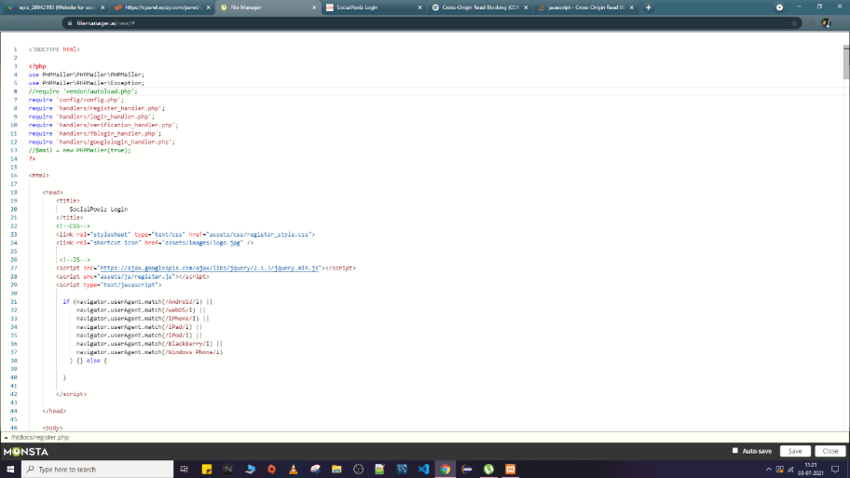

1. Database not connecting

Solution –

Change the config

